Q1.

Q2.

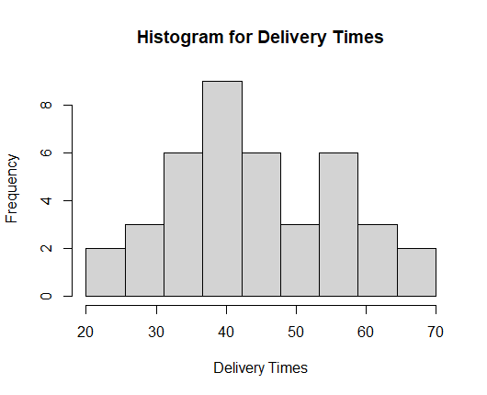

Q3. The distribution of delivery times is **positively skewed** or **right-skewed**. This is because most of the data points are clustered at the lower end of the delivery times, and the tail of the distribution extends to the right towards higher values.

Q4.

